**Assembly language**

**Lab report week 1**

**Group 65**

**Integrants: 110504517 李睿穎 (Leader)，110504518 鍾秉均 (Member)**

Before executing the program

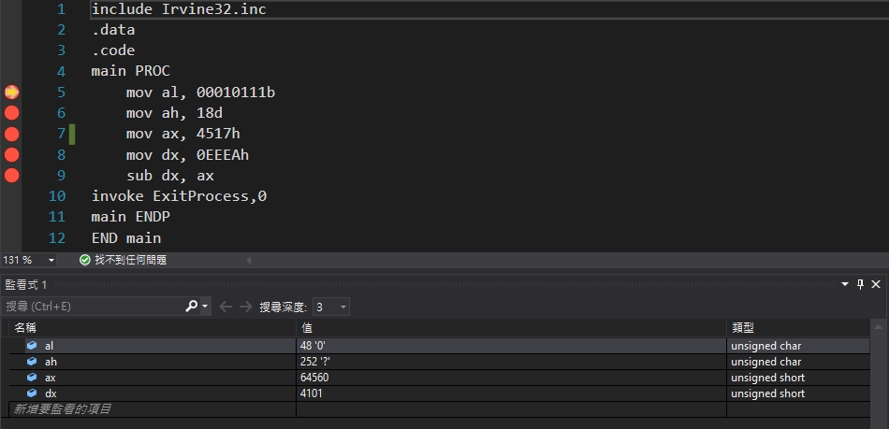

Step (1)

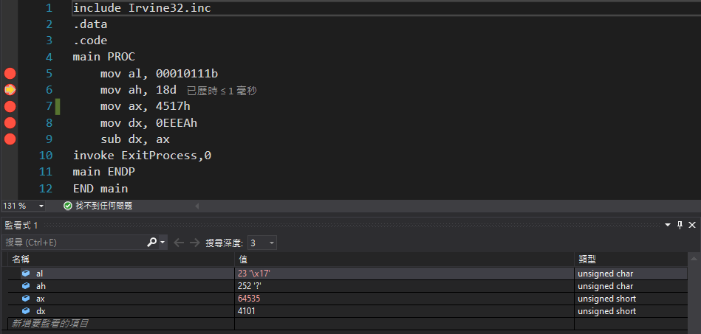



Saving a 8-bit binary data into “al” register, 23 means the decimal coversion of “al”, and 17 means the hexadecimal conversion of “al”

We can observe that “ax” also got affected.

Step (2)

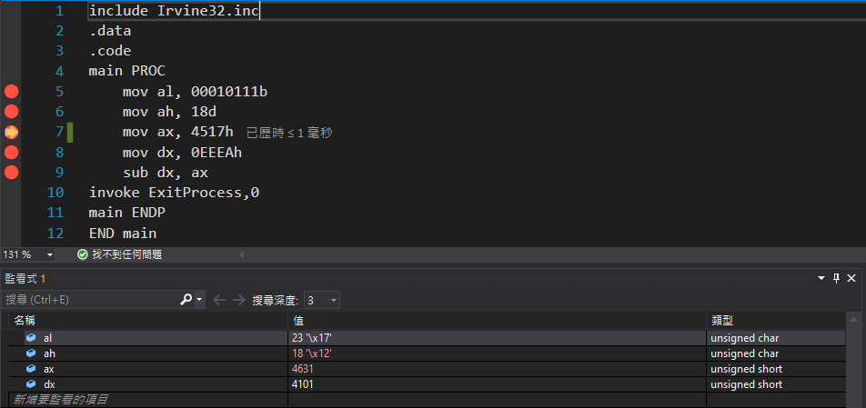

Saving a decimal data into “ah” register, 18 means the decimal of “ah”, and 12 means the hexadecimal conversion of “ah”

We can observe that “ax” also got affected.

Step (3)

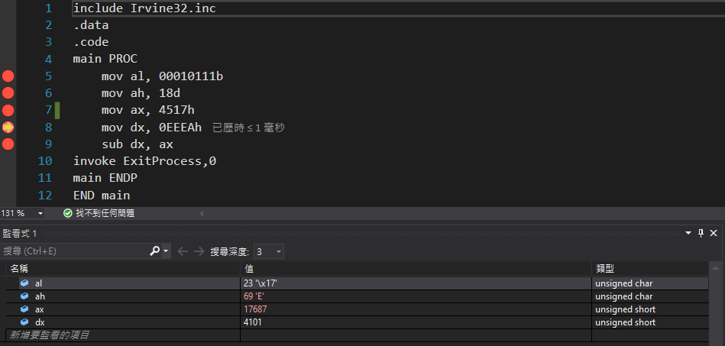

Saving a hexadecimal data into “ax”, 17687 means its decimal conversion.

Same with dx.

We can observe that “ah” got affected.

Step (4)

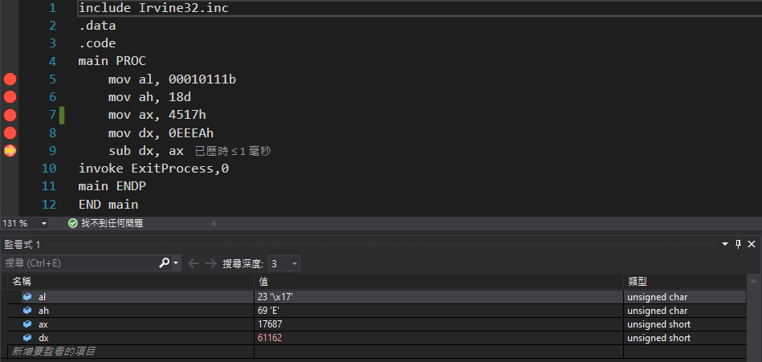

Step (5)

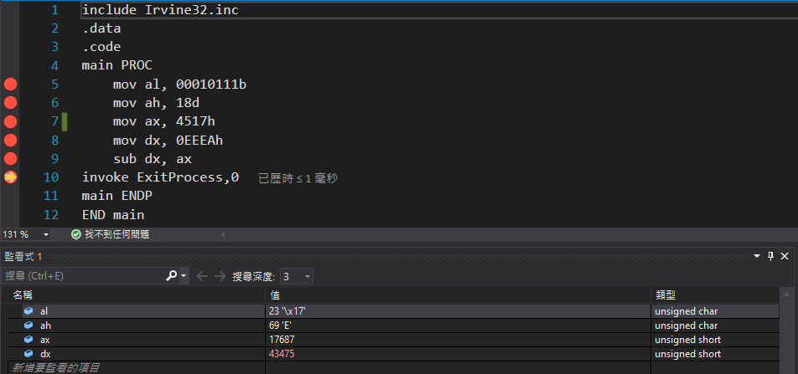

Substracting ax value to dx value. 43475 is the decimal result.

The changes made in the register along execution.

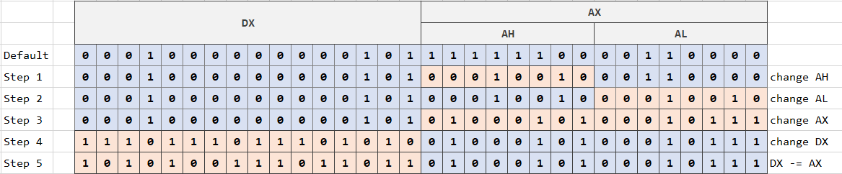

In this experiment apart from learning some basics of the language and how to program on it, we learned how the computer organizes its memory by observing the relation between the registers, we also learned what are the downsides of maximizing efficiency, we think that we need to be careful when wanting to do so. Although we do not need to care for this little things in high level languages, but maybe sometimes we could avoid or solve some mistakes that make no sense in the future.